# **Researched Findings on Front End Frameworks and Libraries**

**React**

React structures the application in a component based hierarchy. Therefore when developing a complex system, react provides an easy development phase since it splits the application features into components. Since React uses a feature called Virtual DOM it provides a fast rendering of DOM. The libraries such as Flux and Redux really supportive when developing a complex system.

**AngularJS**

AngularJS implicitly splits the application into model – view – controller architecture. HTML used as the language to model the views in AngularJS. Also the following features of Angular JS is impressive,

* Service providers where they belong
* Context aware communication
* Unit testing ready
* Flexibility with filters

**Vue**

Vue is a JS UI library. It only requires the basic knowledge in HTML and JS to start with Vue. It’s that simple. Vue supports features such as routing, bundling, component behavior etc. It supports for both complex and simple applications. Another mind blowing feature of Vue is its built in transition effects. (Lynne n.d.)

**Angular 6**

Angular 6 is based on typescript rather than javascript. It uses components and directives to deal with the application logic and the view**.** Comparing to the AngularJS, Angular 6 is faster. Some of other benefits of Angular 6 is,

* TypeScript allows code optimization using the OOPS concept.
* It is mobile-oriented.
* It has improved dependency injection and modularity.
* It provides more choice for languages such as Dart, TypeScript, ES5, and ES6 for writing codes.
* It offers simpler routing.

**Performance Analysis on frameworks**

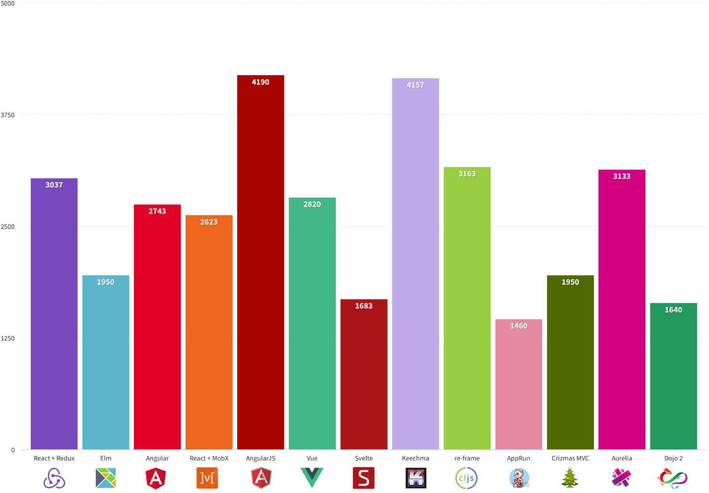

Figure - https://medium.freecodecamp.org/a-real-world-comparison-of-front-end-frameworks-with-benchmarks-2018-update-e5760fb4a962

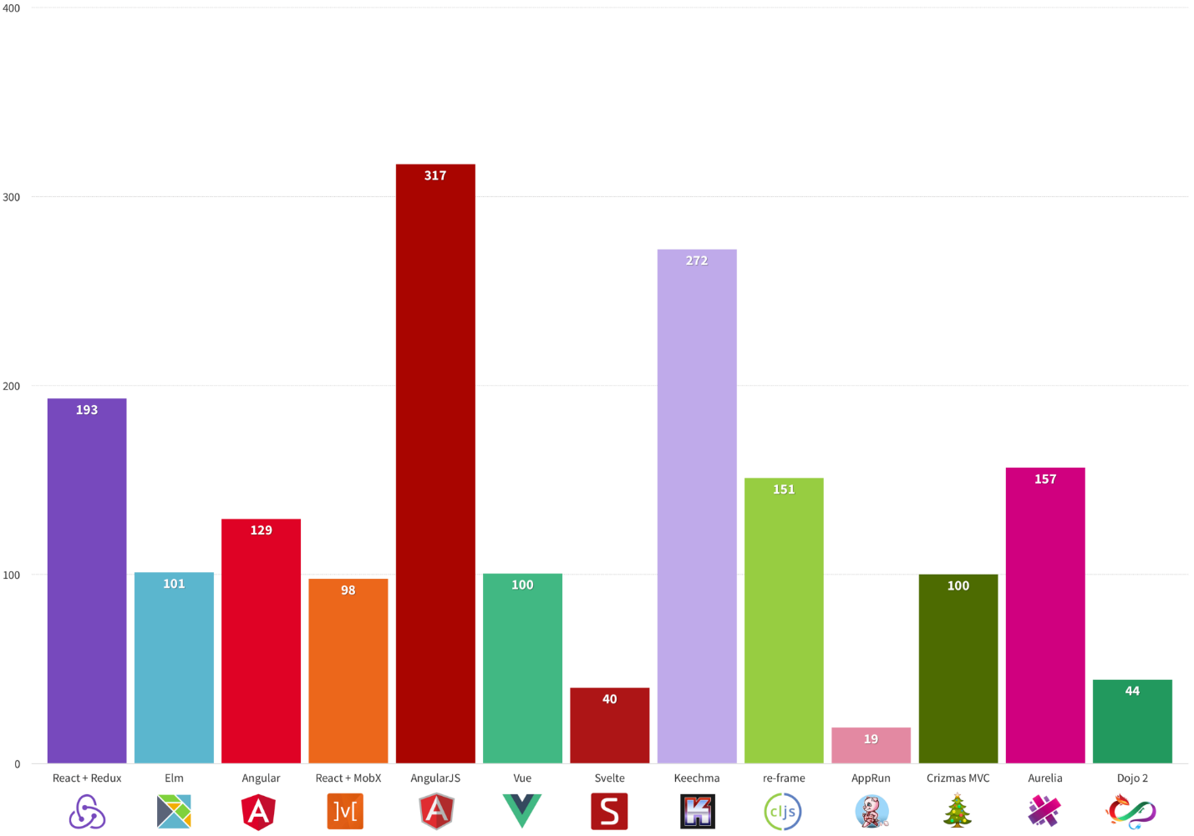**Transfer Size Analysis of Frameworks**

Figure - https://medium.freecodecamp.org/a-real-world-comparison-of-front-end-frameworks-with-benchmarks-2018-update-e5760fb4a962

**Considering Above Findings We selected Angular 6 as the frontend framework for our system**

# References

Lau, Dmitri. 2013. *10 Reasons Why You Should Use AngularJS.* sEPTEMBER 05. Accessed August 16, 2018. https://www.sitepoint.com/10-reasons-use-angularjs/.

Lynne. n.d. *6 Reasons to use Vue.js.* Accessed August 16, 2018. https://dev.to/lynnewritescode/6-reasons-to-use-vuejs-1p6c.

Sahin, Kutlu. 2017. *7 Reasons why you should use React.* January 27. Accessed August 16, 2018. https://stories.jotform.com/7-reasons-why-you-should-use-react-ad420c634247.

Sasikumar, Srihari. 2018. *AngularJS Vs. Angular 2 Vs. Angular 4: Understanding the Differences.* August 02. Accessed August 16, 2018. https://www.simplilearn.com/angularjs-vs-angular-2-vs-angular-4-differences-article.